Lab Exercise 10– Creating Deployment in Kubernetes
Below is a lab exercise that demonstrates how to create and manage a Deployment in Kubernetes.
Step 1: Create a Deployment Configuration File
Create a file named deployment.yaml with the following configuration:
Link of file: (Copy following code from my GitHub repo)
https://github.com/hkshitesh/ACO-LAB-2021-25/blob/main/scripts/deployment.yaml
apiVersion: apps/v1
kind: Deployment
metadata:
name: apache-deployment
labels:
app: web
spec:
replicas: 10
selector:
matchLabels:
app: web
template:
metadata:
labels:
app: web
spec:
containers:
- name: httpd
image: httpd

Step 2: Apply the Deployment Configuration
Apply the configuration to create the Deployment:
kubectl apply -f deployment.yaml
Output -
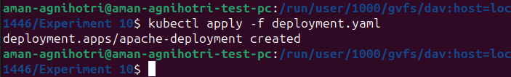
Step 3: View the Deployment and Pods
View the created Deployment and the associated Pods:
kubectl get deployments
kubectl get pods
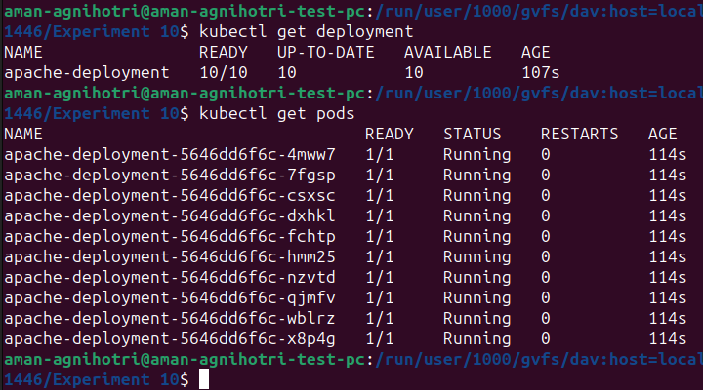
Output -

Step 4: Delete the Deployment
Delete the Deployment:
kubectl delete deployment my-deployment
Output -
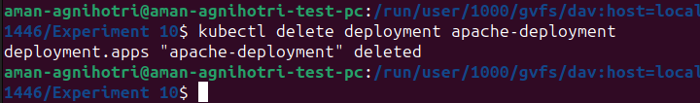
Conclusion
This exercise demonstrated how to create, manage, and update a Deployment in Kubernetes. You learned how to scale the Deployment, update the image, and perform a rolling update to the Deployment. Experiment further with different configurations and update strategies to deepen your understanding of managing Deployments in Kubernetes.

